COAL LAB CLASS TASKS
Task 1:
include Irvine32.inc

.data
a DWORD 20
b DWORD 10
cval DWORD 6
d DWORD 2
res DWORD ?
.code
main PROC
mov eax,a
mov ebx,b
add eax,ebx
mov ebx,eax
mov eax,cval
mov edx,d
mul edx
mov ecx,eax
mov eax,ebx
sub eax,ecx
mov res,eax
call writeInt
exit
main ENDP
END main
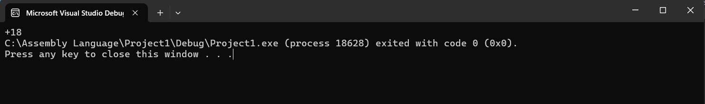
Task 2:
include Irvine32.inc

.data
area DWORD ?
msg BYTE "Area of triangle is ",0
.code
main PROC
base = 10
height EQU 5
mov eax,base
mov ebx,height
mul ebx
mov edx,0
mov ebx, 2
div ebx
mov area,eax
mov edx,offset msg
call writeString
call writeInt
call crlf
exit
main ENDP
END main
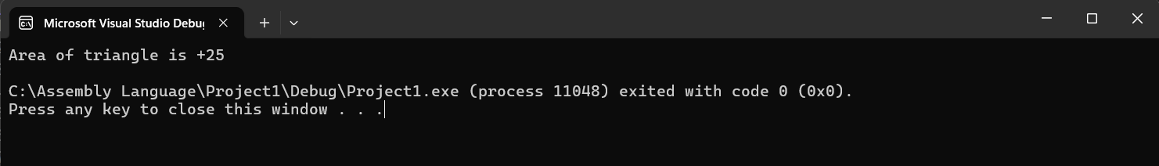
Task 3:
include Irvine32.inc

.data
net_salary DWORD ?
msg BYTE "Net Salary is ",0
.code
main PROC
base_salary = 25000
leave_deduction = base_salary/30
overtime_allowance = 600
leaves = 3
overtime_hours = 5
mov eax,leaves
mov ebx, leave_deduction
mul ebx
mov ecx,eax
mov eax,base_salary
sub eax,ecx
mov ebx,eax
mov eax,overtime_hours
mov ecx,overtime_allowance
mul ecx
add eax,ebx
mov net_salary,eax
mov edx,offset msg
call writeString
call writeInt
call crlf
exit
main ENDP
END main
